DataStage Password change procedure:

Datastage Servers:

Production : b01aciisd004.ahe.pok.ibm.com

Pre-Prod: b01aciisd002.ahe.pok.ibm.com

pre-requesties:

We need to change diosetl' id's password in AIX box and as well as in application URL. To get application URL we need to add server host names in /etc/hosts file of your system:

9.57.53.116 b01aciisd002.ahe.pok.ibm.com b01aciisd002.ahe.pok.ibm.com b01aciisd002 b01cxnp21062

9.57.53.122 b01aciisd004.ahe.pok.ibm.com b01aciisd004.ahe.pok.ibm.com b01aciisd004 b01cxnp21060

Application URL's:

Pre-prod ---- http://b01cxnp21062:9080/ibm/iis/console/

Production-- http://b01cxnp21060:9080/ibm/iis/console/

- Confidential: id and password to login to application URL's

wasadmin/g7ihrh7q ( same for both prod and pre-prod)

Caution: Please make sure to login to correct URL while changing password. Doubel check before proceeding to password change.

dsuser, fscdsid,csiuser, scspprod@us.ibm.com, scdsods@us.ibm.com are the DataStage user id's and you can get password from /var/datastage/scripts/varcreds.config file of DataStage Server.

And file owned by diosetl

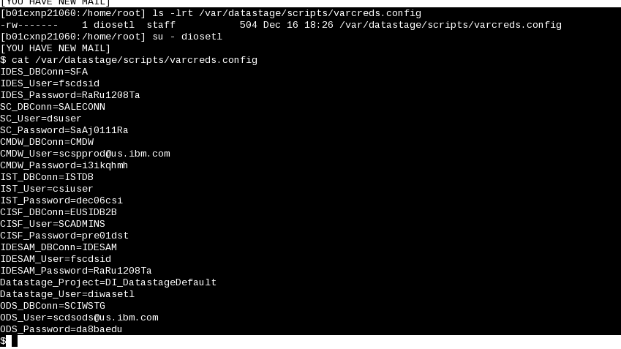

Please pull the old passwords and keep it handy before proceeding to password change ….

dsuser password change procedure:

dsuser id actually exists on SC db servers ( prod: rdb024 and rdb025, pre-prod rdb019 & rdb020)

- Login to db servers as dsuser ( not as root) and change them:

Ex: ssh aramiset@g01acirdb025.ahe.pok.ibm.com

su – dsuser

- Change password for dsuser:

passwd

- Logout from g01acirdb025.ahe.pok.ibm.com server.

- repeat the same for other server I.e g01acirdb024.ahe.pok.ibm.com

After dsuser password change on db servers:

- Change dsuser password in varcreds.config file on DataStage Server:

su - diosetl to datastage server, b01aciisd004.ahe.pok.ibm.com
cd /var/datastage/scripts/
vi varcreds.config , update password for 'SC_Password'

2.Then run GenerateParamFiles.sh (./GenerateParamFiles.sh)

fscdsid password procedure:

Actually fscdsid id exists on b01acirdb071.ahe.pok.ibm.com server.

- Login to b01acirdb071.ahe.pok.ibm.com server as fscdsid and change password using 'passwd' command
I. ssh fscdsid@b01acirdb071.ahe.pok.ibm.com
11.passwd ---- and change password
- fscdsid password change on DataStage server (b01aciisd004.ahe.pok.ibm.com) :

su - diosetl to datastage server,
cd /var/datastage/scripts/
vi varcreds.config , update password for 'IDES_Password' and 'IDESAM_Password'
Then run GenerateParamFiles.sh (./GenerateParamFiles.sh)

Note: fscdsid is used by RTC_59675 so need to also manually update password for fscdsid in /var/datastage/scripts/parmfiles/RTC_59675_ParamsUpd.txt
cd /var/datastage/scripts/parmfiles
vi RTC_59675_ParamsUpd.txt
update password value for IDESAM_DB_ParamSet.Password

Changing csiuser id's password: ( )

Changing
su - diosetl to datastage server, b01aciisd004.ahe.pok.ibm.com
cd /var/datastage/scripts/
vi varcreds.config , update password for 'IST_Password'
Then run GenerateParamFiles.sh (./GenerateParamFiles.sh)

Note: csiuser id is used by RTC_59675 so need to also manually update password for csiuser in /var/datastage/scripts/parmfiles/RTC_59675_ParamsUpd.txt
cd /var/datastage/scripts/parmfiles
vi RTC_59675_ParamsUpd.txt
update password value for IST_DB_ParamSet.Password

Changing scspprod@us.ibm.com id's password:

This id owned by David and he changes it from his end and passes password to us. Our team just need to update it in varcreds.config file in DataStage server

su - diosetl to datastage server, b01aciisd004.ahe.pok.ibm.com
cd /var/datastage/scripts/
vi varcreds.config , update password for 'CMDW_Password'
Then run GenerateParamFiles.sh (./GenerateParamFiles.sh)

Changing scdsods@us.ibm.com id's password:

This id owned by David and he changes it from his end and passes password to us. Our team just need to update it in varcreds.config file in DataStage server

After scdsods@us.ibm.com password change:
su - diosetl to datastage server, b01aciisd004.ahe.pok.ibm.com
cd /var/datastage/scripts/
vi varcreds.config , update password for 'ODS_Password'
Then run GenerateParamFiles.sh (./GenerateParamFiles.sh)

diosetl password change procedure:

Actually diosetl password exists in b01aciisd004.ahe.pok.ibm.com server.
Change that password using :

su – diosetl
passwd and change it

After diosetl password change:
(credential mapping change to be performed by web/datastage admin or SC admin team)

From ds windows admin client, b01wciisd001.ahe.pok.ibm.com ( can do it from our loacal as well , if we change hosts file) :

http://b01cxnp21060:9080/ibm/iis/console/ , ( cross check before login)

login as isadmin or wasadmin ( credentials shared above)

- In the Administration tab, Click Domain Management > Engine Credentials

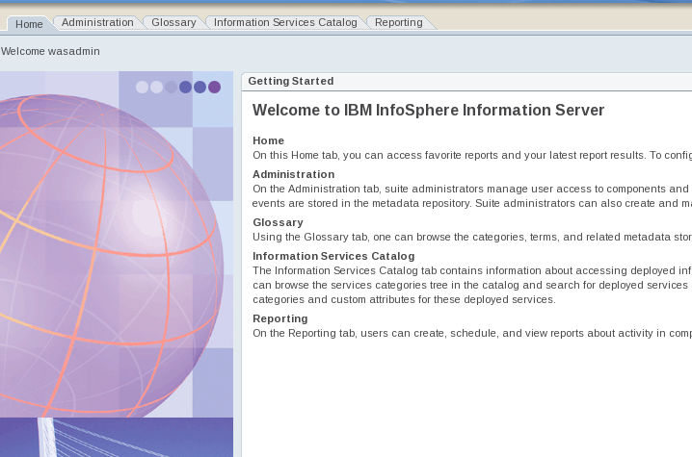

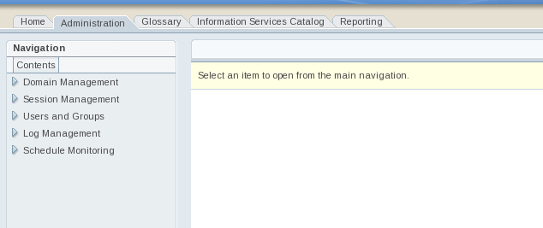

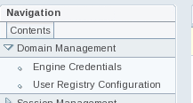

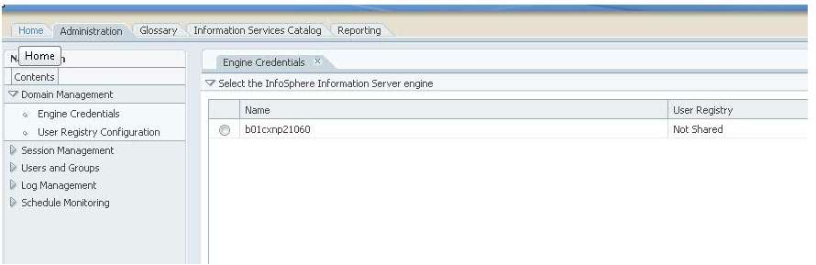

- Select the choice of $DATASTAGE_HOST (should be the prod datastage server, b01cxnp21060)

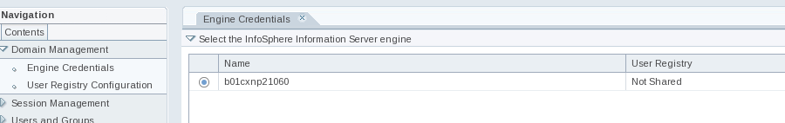

- At the right hand side, click on 'Open User Credentials'

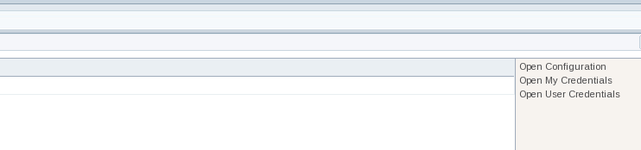

- Click 'Browse' button, select diwasetl, click 'OK'

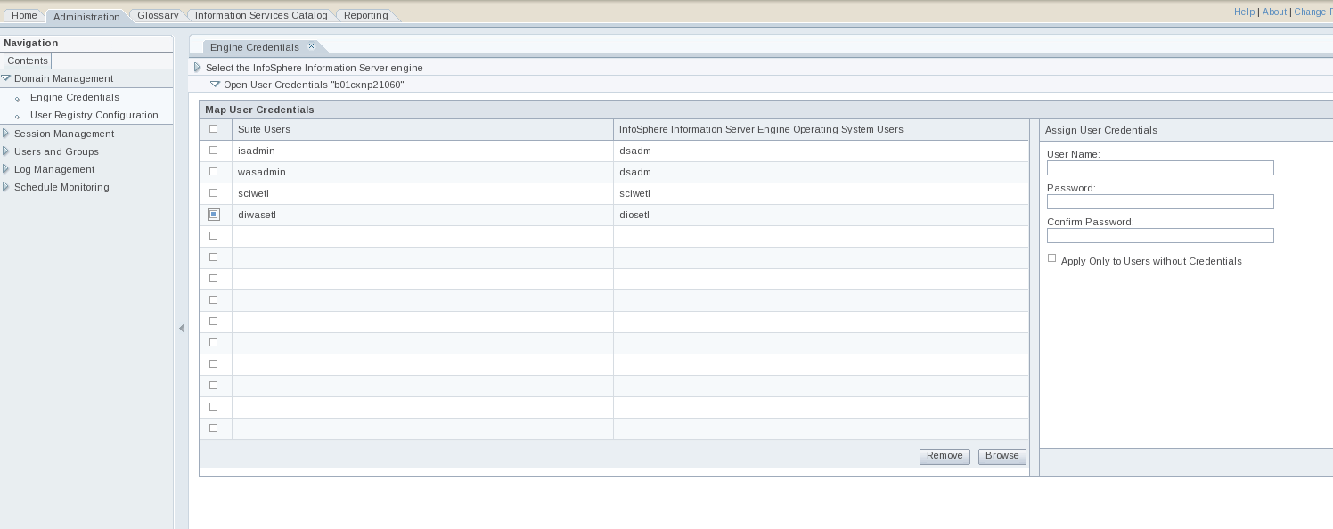

5. At the right hand side, 'Assign User Credentials', type in
User Name:diosetl
Password: <new password>
Confirm Password: <new password>

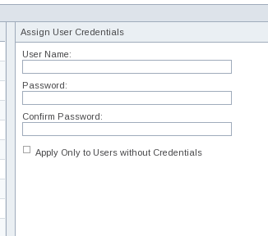
6.Click 'Apply' at the bottom scroll down all the way, click Apply and Close.

After completion of password change, please check db connectivity using id and respective password.

You can get those details from /var/datastage/scripts/varcreds.config
ex:
$ db2 connect to SFA user fscdsid
Enter current password for fscdsid:

Database Connection Information

Database server = DB2/AIX64 9.7.8
SQL authorization ID = FSCDSID
Local database alias = SFA

$ db2 connect to saleconn user dsuser
Enter current password for dsuser:

Database Connection Information

Database server = DB2/AIX64 10.1.4
SQL authorization ID = DSUSER
Local database alias = SALECONN

$

- scdsid ( scdbid on pre-prod ) password change procedure:

scdsid id actually exists on SC prod db servers ( prod: rdb024 and rdb025)
scdbid id exists on pre-prod servers ( rdb019 & rdb020)

- Login to db servers as scdsid ( not as root) and change them:

Ex: ssh aramiset@g01acirdb025.ahe.pok.ibm.com

su – scdsid

- Change password for dsuser:

passwd

- Logout from g01acirdb025.ahe.pok.ibm.com server.

- repeat the same for other server I.e g01acirdb024.ahe.pok.ibm.com

After password change for scdsid on db servers:

This id is used by RTC_59675 job and password need to be updated manually in RTC_59675_ParamsUpd.txt file.
cd /var/datastage/scripts/parmfiles
vi RTC_59675_ParamsUpd.txt
update password value for SC_DB_ParamSet.Password

Note: Every time after executing run GenerateParamFiles.sh (./GenerateParamFiles.sh) we need to manually change RTC_59675_ParamsUpd.txt without missing with passwords of scdsid, fscdsid and csiuser.

In this section shown below from your document, please add the following note:
=============================================================================================================================
Changing csiuser id's password: ( )

Note: csiuser id is used by RTC_55514 so need to also manually update password for csiuser in /var/datastage/scripts/parameters_55514.txt
vi /var/datastage/scripts/parameters_55514.txt
update password value for IST_DB_ParamSet.Password
=============================================================================================================================

We need to make this similar to other jobs where we only update varcreds.config and run GenerateParamFiles.sh, but currently we dont have that for this file, I will get that fixed soon but in the interim we need to do the above process whenever csiuser pw changes

- After completion of password change, Please send new passwords to team in confidential mail
- Please check RTC_59675_ParamsUpd.txt everytime after executing ./GenerateParamFiles.sh without missing

